1. Mention the powder XRD peak positions for the prepared by SnO2 nanoparticles in methanol. (Use the diffractogram given in Slide no. 10).

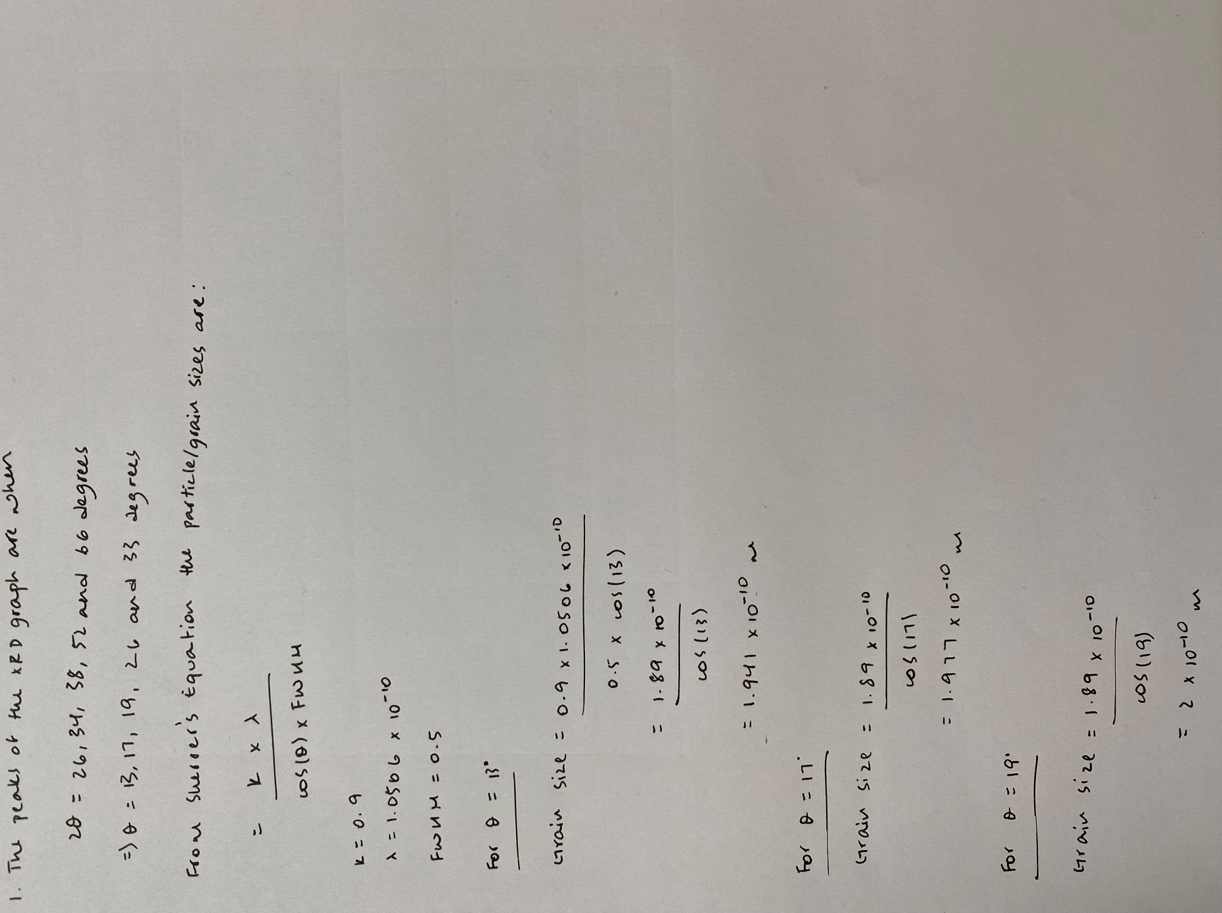2. Calculate the crystallite size using Scherrer’s equation if: k = 0.9, λ = 1.0506 Å, FWHM = 0.5 radian, and θ = 11 degree

